Pretty paper title problems

1. A Management Accounting Model on Revenue Based on Data Integeration under EC Circumstances

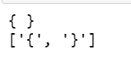

(程式碼呈現結果)

(原始論文)

若論文裡有公式或數學運算符號，雖然肉眼看起來字的大小一樣，但程式辨別的大小差很多。

1. A Multi-party Secure SaaS Cloud Accounting Platform Based on Lattice-based Homomorphic Encryption System

有多篇論文的程式碼結果會呈現此論文的編號

1. Account charting and financial reporting at accounting module on Enterprise Resource Planning using tree traversal algorithm

若論文標題有換行，會出現只讀到某一行的問題

1. Accounting Stability, Ownership Characteristics and the Effectiveness of Compensation Contract -- Empirical Study of 2007-2010 China Listed Companies



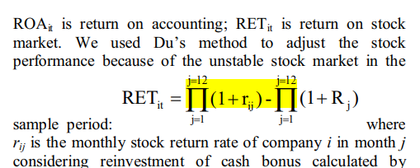

1. An Empirical Study on the Fluctuation of Accounting Information Quality



1. Analyses on Innovation of Accounting System Based on Strategy of Recycle Economy



1. Application of activity-based costing quality cost accounting research



編碼問題，已嘗試過 encoding='utf-8'，但無效。

1. Cloud Accounting The Transition of Accounting Information Model in the Big Data Background



1. Computer auxiliary accounting research of environment accounting software



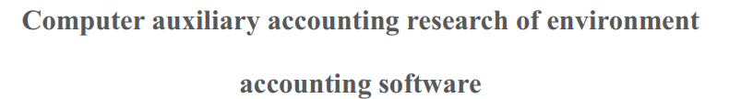

1. Construction and Application of Accounting Information Platform based on Big Data Environment



1. Current Account_s Budget Constraints for Capital and Financial Account



1. Development of an Application for Expense Accounting

